

**Survival Analysis**

**Project 2**

**Group 9**

**Xueling Chen**

**Yu Li**

**Vinit Gupta**

**Rahul Manchanda**

**Pawan Shivhare**

**Rajarshi Das**

**Executive Summary**

This report and this part of the project is an extension to the first part of the project, where this report is tried to find better answers on some of the key factors associated to employee attrition and how those factors are contributing towards the employee attrition towards the different employee group level. The project has looked upon the different types of turnover and reduce the types to 3, and considering affects and contribution of various parameters which are time sensitive like for example employee bonus, monthly income etc. and also dealt with non-proportionally problems. Based on the detailed analysis the project has identified that a significant proportion of the employees are leaving the organization not just for one or two reasons but due to multiple reasons. The project found out that there are several interesting contributors for attrition for different groups and has described those findings and issues in this report in a detailed fashion based on the statistical analysis. In this part of the project, it uses very specific survival analysis concepts and procedures (as directed in the project flyer) for doing the analysis. At the end, the report provided a summary of findings as well as some carefully thought out recommendations for the CEO and management team of the ‘Fermalogis’, there might be some limitations associated to implementations of all the recommendations at the same time, but if these items are at least monitored by the management team, it can definitely give them better insights on how to contain the employee attrition in a long run, increasing the efficiency and productivity of the organization.

**Statement of Problem**

In this section of the project, the goal of this project was to employ the fundamentals of survival analysis to answer many business questions associated to employee turn overs at different employee group levels of turn over. The previous analysis was superficial at many levels, as it has not employed deeper analysis and investigation on questions as follows

* What will be the effect of the result of analysis if it combine different event types?
* What are the attributes that increase of decrease the hazard rate?
* How the bonus does affects the turn over?
* Also, if there are any other significant factors which is affecting the turnover, like for example age of the employee etc.

So, in this 2nd part of the project, as you can see in the detailed section below, the project have tried to investigate these problems by employing both the competing risk concepts and predominantly using the Cox regression model for analysis of the time-dependent covariate.

**Background**

All the analysis of this section of the project, is an extension of the first part of the project, which originally stared based on a request from the COO of the famous pharmaceutical company ‘Fermalogis’ as the COO was interested to see how the team, having the knowledge of the cutting edge ‘Survival analysis’ techniques, can utilize those knowledge to identify the issues associated to employee attrition in his company. The project 2 has used the data provided by the company.

**Data Processing and Exploration**

1. Recode the variables

For this dataset, there are some variables recoded from character to nominal type to simplify the analysis work. Here is the summary of the recoding variables.

|  |  |
| --- | --- |
| Column Name | Explanation |
| Over18 | 1: Y  0: N |
| OverTime | 1: Yes  0: No |
| JobRole | 1: Healthcare Representative, Research Director, Manager Manufacturing Director  2: Laboratory Technician, Sales Representative  3: Human Resources, Manager, Research Scientist, Sales Executive |
| Gender | 1: Male  0: Female |
| Type | 0: No Turnover  1: Retirement  2: Voluntary Resignation  3: Involuntary Resignation  4: Job Termination, Employee is fired |

1. Data Exploration
2. Potential variables that may affect the turnover frequency

* Age

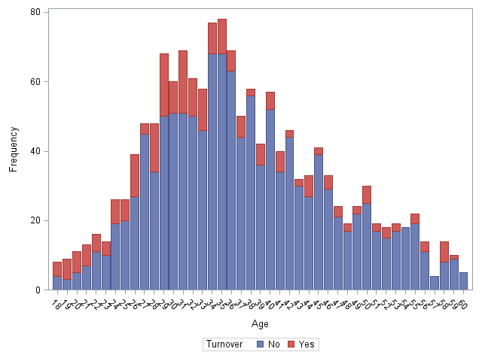

When analyzing the turnover rate of each age, it shows when employees’ age is younger than 34, turnover rate is higher. By contrast, when employees’ age is older than 40, turnover rate become very low and stable.

* Years at current role

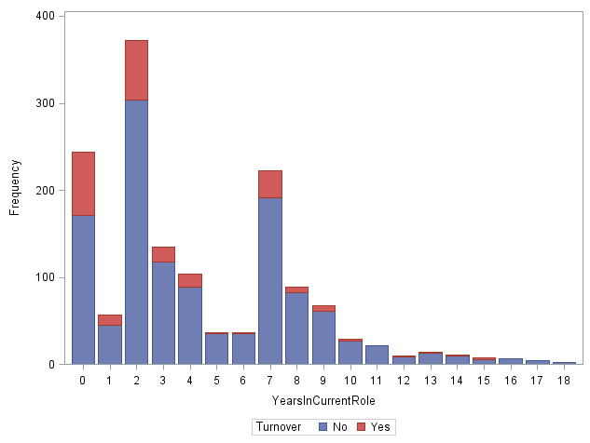

It is obvious that when an employee stays in a role less than 4 years, he is more apt to leave the current position.

* Monthly Income

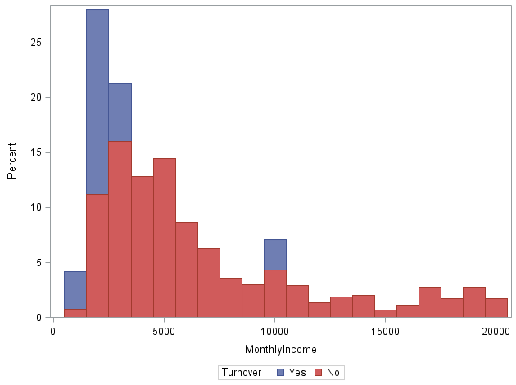

When monthly income increases to $5000, turnover rate decrease a lot. For the employees whose income is less than $3000, they are more willing to leave the company.

1. Variables performance based on event type

* Relationship Satisfaction

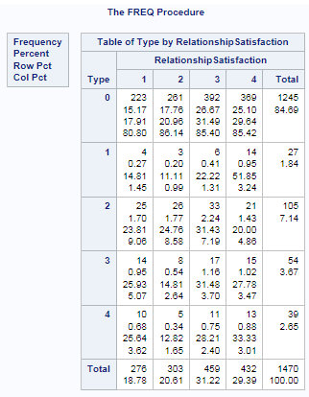

The people who do not leave the company have a higher satisfaction for colleague relationship. So relationship may be an important factor to affect turnover rate.

**Analysis**

1. Event Type Analysis
2. Does the different event type perform significantly differently?

We have 4 event types, when analyzing the survival and hazard rate of the observations, whether these types have different coefficient should be a very important thing to consider.

So the first thing should do here is to find out if these event types are significantly different and should be analyzed separately or not.

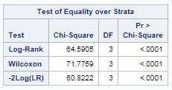

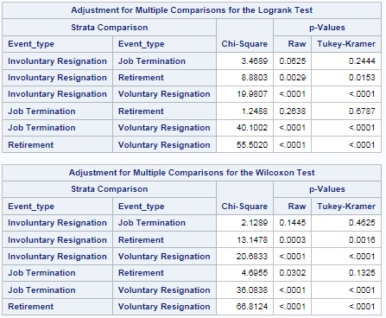

Based on p-value, voluntary resignation is significantly different from all other 3 types. Job termination is close to involuntary resignation and retirement. And all others are different.

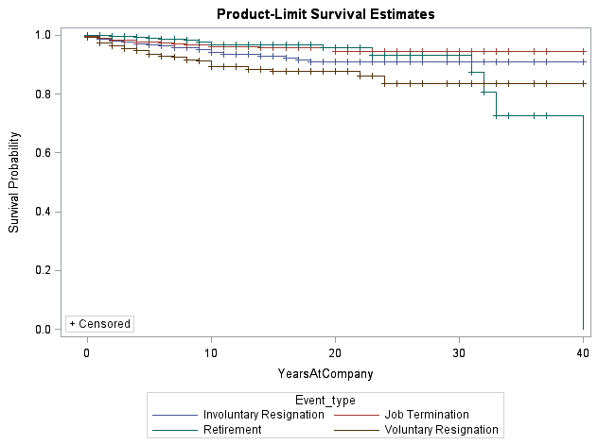

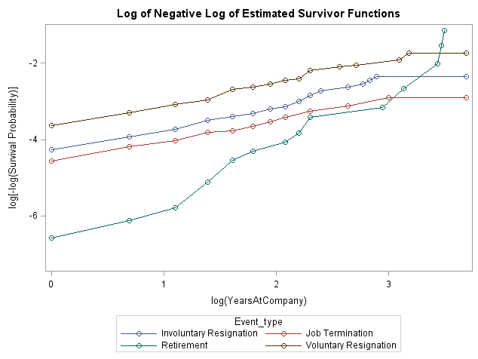

From the survival probability estimation and log chart, it indicates that retirement has a different performance among each other. So can say these event types have different results. Therefore it is necessary to compare the different combined models with unseparated model to see whether it should be considered separately for each event type, also say whether they can use the same coefficients for building models.



Firstly, separate each event type and use all variables to do comparison, and can find that p-value is almost zero (p-value<0.05), means the type separated models has the significant difference with the unseparated model. So it is sure that the type should be separated.

But it is not sure whether they should be all separated or not, in the next step the project is going to test and make the final decision.

1. **Does it need to separate all of them?**

From previous analysis, it shows voluntary resignation is significantly different from all others, yes, it is obvious that should separate it from other event type. But how to deal with job termination, involuntary resignation and retirement?

Firstly, do the test to see whether Retirement and Job Termination should be separated.



From p-value, can say retirement and termination are different, so should separate them as 2 different event type, they cannot use the same coefficients for the model.

Then, test the Involuntary Resignation and Retirement.



Based on the analysis finds that the models of Involuntary Resignation and Job Termination are not significantly different, means they can use the same coefficients for modeling. So type 3 and type 4 can be combined together as type 3 in further analysis.

In conclusion, in this case it originally has 4 different event type and they have differences. Based on further analysis found that Involuntary Resignation and Job Termination could be combined together as one type, and also separate the turnover type of Retirement and Voluntary Resignation, which finally has 3 types.

1. **Attributes Analysis**
2. **Type1 – Retirement**

This project contains so many categorical variables so use one-way test first to check if these categories have very different effect on event.

We do the Education Field, Job Role, Job Level, Environment Satisfaction and Education test for Retirement and find those categories do not have significant difference on this event.

Then use stepwise – backward selection here to choose significant variables and 23 variables are chosen to be removed.

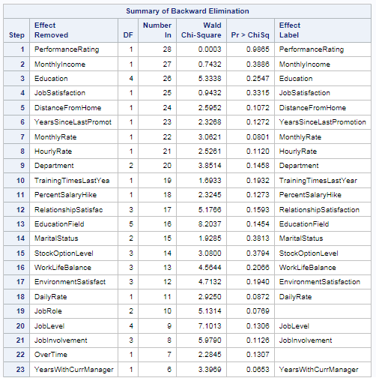

The left variables are used to do the PHREG test.

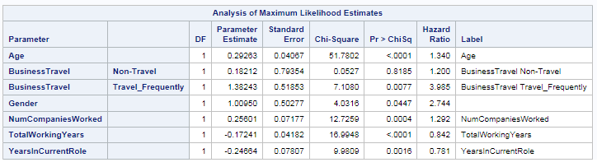

**Conclusion:**

Age, Business Travel (Travel frequently), Gender and Number of Companies Worked can increase the hazard rate on retirement. Total Working Years and Years at Current Role can decrease the hazard rate on retirement.

1. **Type 2 – Voluntary Resignation**

Similar as previous analysis for type 1, analyzing the variables which have more than 2 categories first to see if each category performs differently.

For Education Field, they do not perform very differently. But for Job Role, each category is very different from each other.

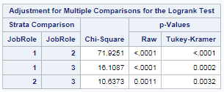

For Job Level, level 1 is quite different from level 2-5; the second level is also different from the highest level – 5.

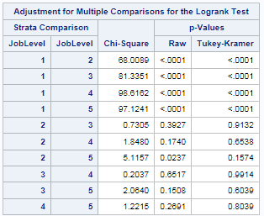

For Job Satisfaction, level 1 is also different from others.

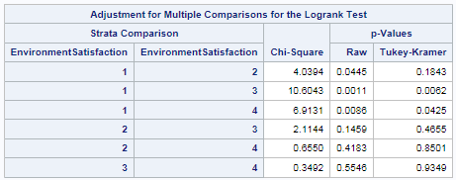

For Education, level 1 is different from 3 and 4; 2 is different from 3; 3 is different from 4 and 5; 4 is different from 5. So when education level is higher, they have very different effect on turnover rate.

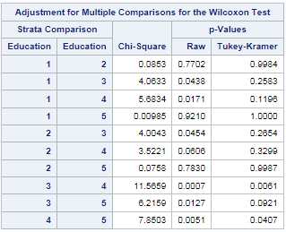

Then use stepwise – backward method to select proper variables in this model.

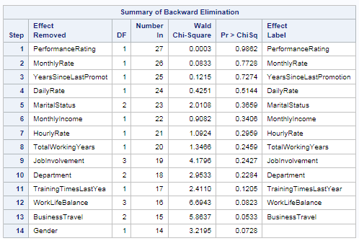

From SAS analysis, 14 variables are not that significant and hence removed from model.

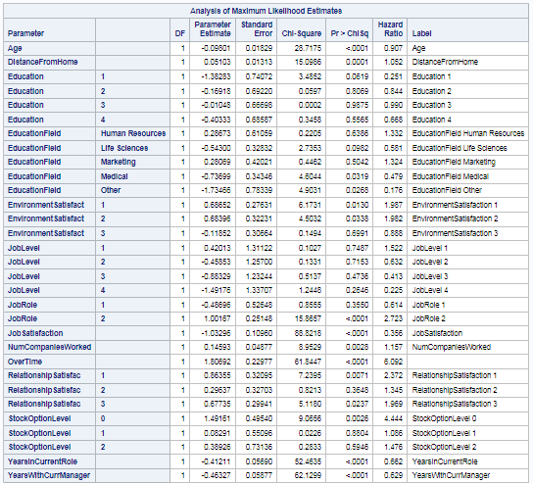

**Conclusion:**

Age, Education Field – Life Sciences, Medical & Other, Job Satisfaction, Year at Current Role and Year with Current Manager have negative effect on the event – Voluntary Resignation.

Distance from Home, Environment Satisfaction 1 &2, Job Role – 2, Number of Companies Worked, Over Time, Relationship Satisfaction -1 & 3, Stock Option Level – 0 & 2 have positive effect on the event - Voluntary Resignation.

1. **Type 3 - Involuntary & Termination**

Based on backward analysis, 14 variables are removed

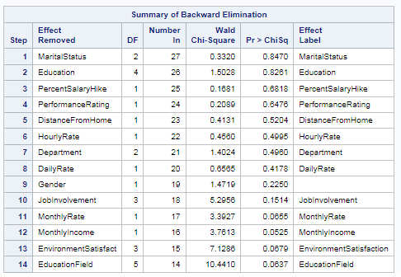

Based on analysis, 14 variables are removed from model.

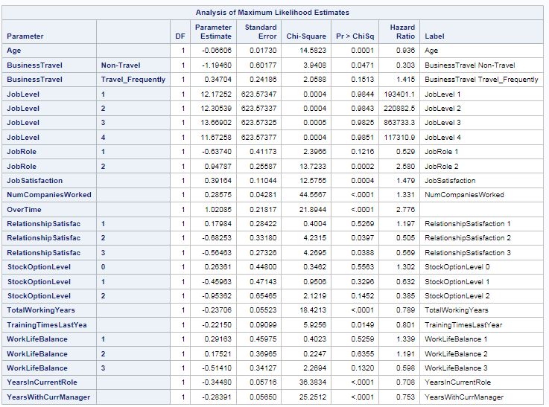

**Conclusion:**

Age, Business Travel – Non travel, Relationship Satisfaction – 2 & 3, Total Working Years, Years in Current Role and Years with Current Manager have significantly negative effect on the event – Involuntary Resignation & Termination.

Job Role -2, Job Satisfaction, Number of Companies Worked, Over Time have significantly positive effect on the event – Involuntary Resignation & Termination.

1. **Bonus Analysis**

Bonus is a time-dependent variable in this project and whether or not an employee can gain bonus depends on whether he/she stays in the company last year. In this part, the project aims to make Bonus as a time-covariate and analyze if it has effect on different event and how it affects different event type.

In this case, only consider bonus 1 to 39, not include bonus 40 because the longest year an employee stay in the company is 40 in this dataset, and bonus depends on his last year.

1. **Type 1 – Retirement**

At first, do the test to check if bonus in the last year and the year before last year have significant effect on retirement.

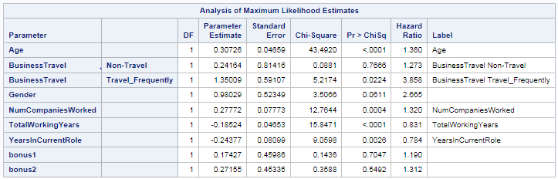

In this table, bonus1 is the effect of bonus in last year, bonus2 is the effect of bonus in the year before last.

**Conclusion:**

According to p-value, can see both of them are insignificant. So can conclude that whether or not an employee has bonus in previous 2 years cannot significantly affect retirement.

Next, use cumulative bonus to do test and analyze if it affects employee turnover.

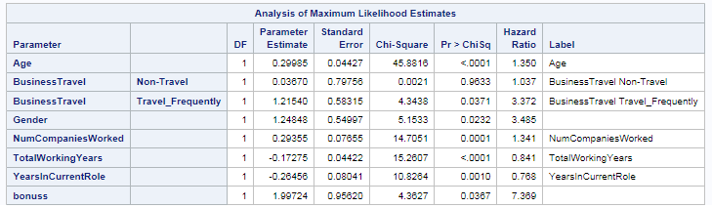

**Conclusion:**

Bonus in this table means cumulative bonus, from p-value, find that cumulative bonus is an effective factor to affect employee turnover and it has a positive effect on event and increase hazard ratio of event, which means the more bonus an employee has before, the higher probability he chooses to retire.

1. **Type 2 – Voluntary Resignation**

In this table, need to focus more on last 2 parameters.

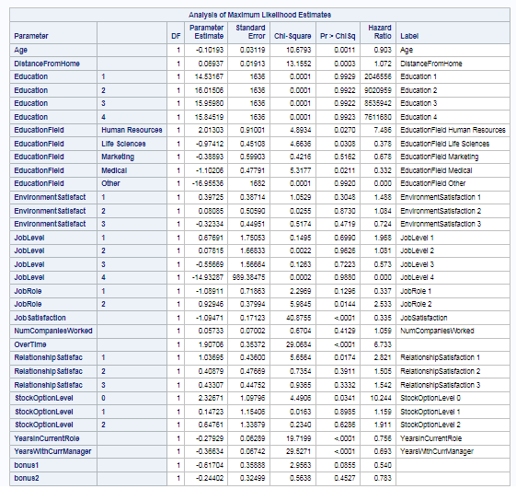

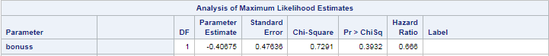

**Conclusion:**

According to p-value, whether an employee has bonus in previous 2 years does not have significant effect on Voluntary Resignation. Also, even consider cumulative bonus in previous year here, this still cannot have significant effect on the employees who are volunteer to leave.

1. **Type 3 – Involuntary Resignation & Termination**

The first table in the effect of bonus in last year and the year before last and the second table show the effect of cumulative bonus.

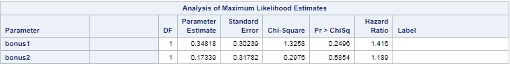



**Conclusion:**

Both the bonus in previous 2 year and cumulative year do not have significant effect on the event – Involuntary Resignation and Termination.

According to analysis of all 3 type events, can conclude that bonus, in cumulative way, do have positive effect on Retirement. In all other situations, bonus cannot work very well to decrease employee turnover rate.

1. **Non-proportionality Analysis**

Some variables are time-dependent, so it may change as time change. If could define the time-covariates and deal with them properly, it will have a better understanding on employee turnover.

In this part, also do analysis based on 3 different type.

1. **Type 1 – Retirement**

**Martingale Residual Method**

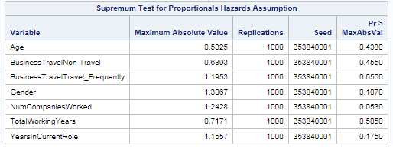

By finding covariates deviating significantly from theoretical expectations under the proportionality assumption, there do not have significant variables that should be time – dependent.

**Shoenfeld Residuals Method**

Firstly, try to plot residuals of some variables to see if they are smooth.

Age

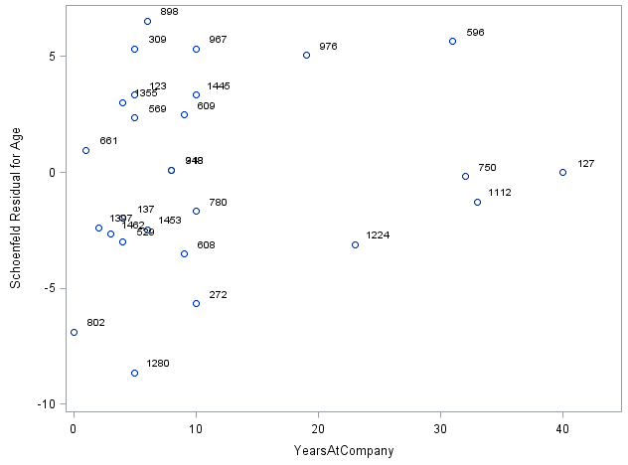

Number of Companies Worked

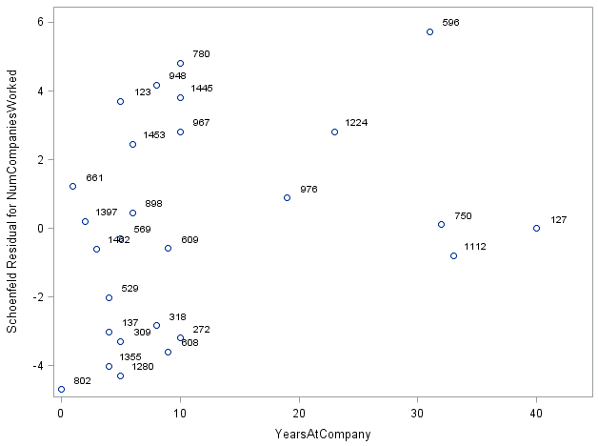

Total Working Years

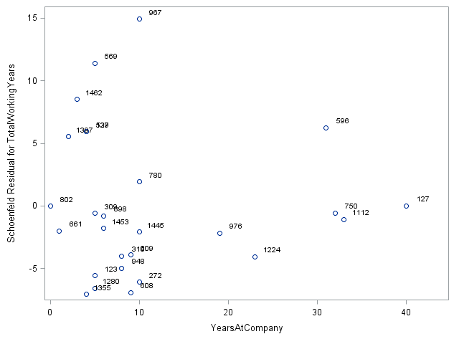

Then check the p-value to see which variables are non-proportional.

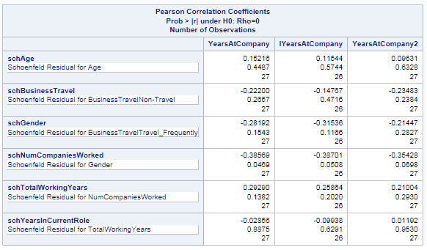

From the table can see only Number of Companies Worked interacts with Years at company. So should take care of this variables in the model next.

Run the model with dealt time-dependent variables.

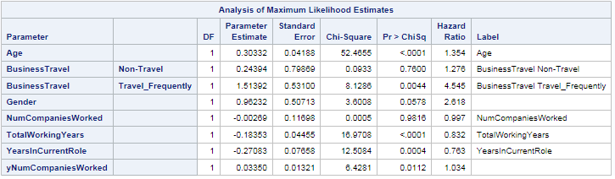

**Conclusion:**

From the model, can see Number of Companies Worked is a time-dependent covariates and has a positive effect on event.

1. **Type 2 – Voluntary Resignation**

**Martingale Residual Method**

Based on residual deviation and p-value, find 4 time covariates.

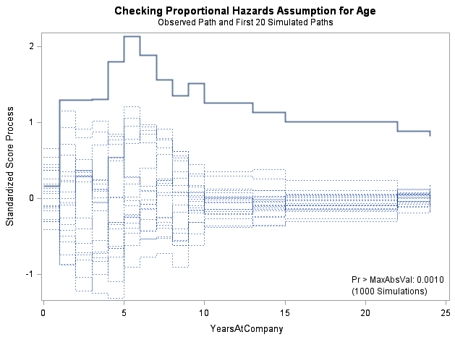

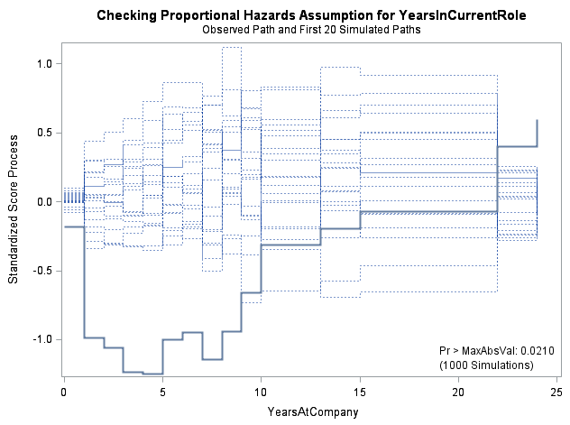

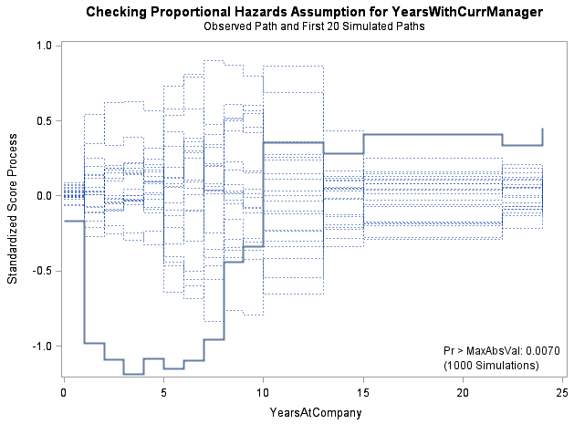

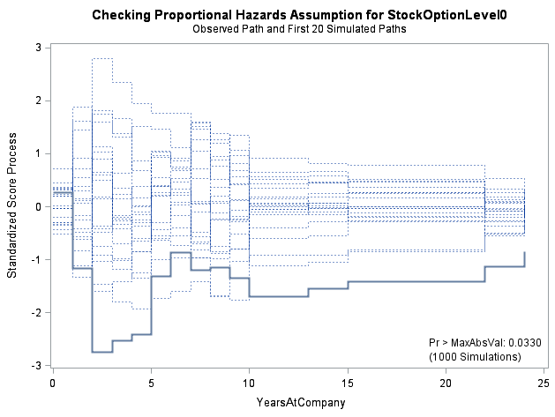

**Shoenfeld Residuals Method**

Age

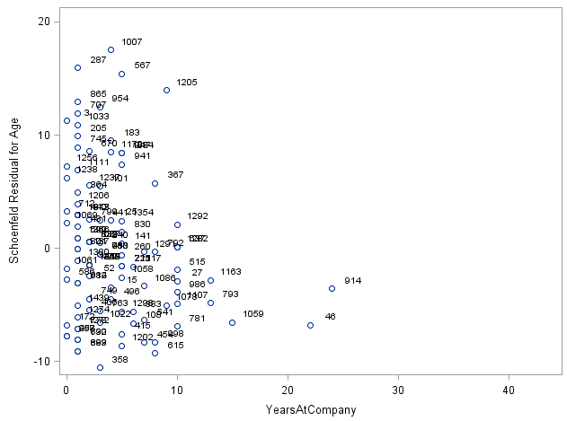

Years in Current Role

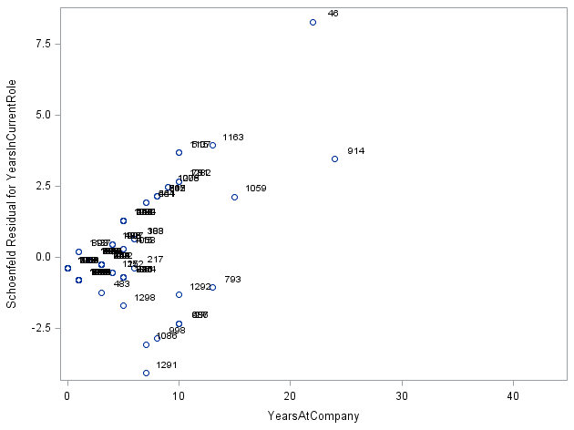

Years with Current Manager

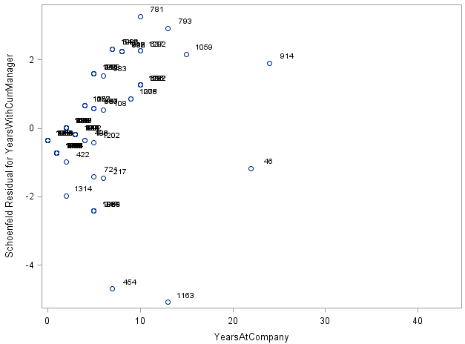

Stock Option Level 0

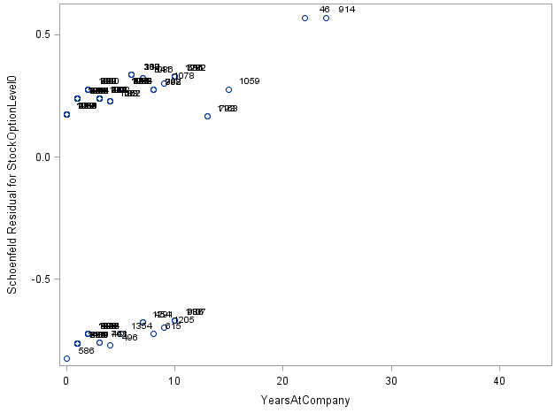

Check non-proportionality based on p-value.

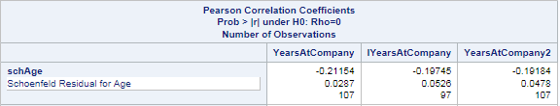

From these 2 method, considering Age, Years in Current Role, Years with Current Manager and Stock Option Level 0 could have non-proportionality. So put them in model with time interaction and run again to see if they are significant.

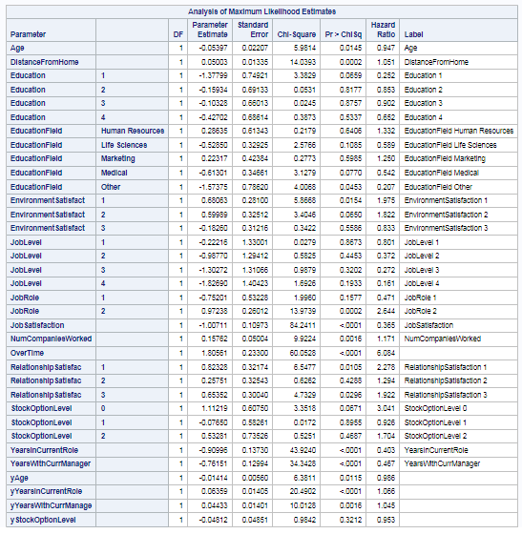

**Conclusion:**

Age, Years in Current Role and Years with Current Manager are time-dependent variables. Age has a negative effect on the second type event; the other 2 have positive effect.

1. **Type 3 – Involuntary Resignation & Termination**

**Martingale Residual Method**

According to analysis, Job level 1, Years in Current Role, Years with Current Manager could be non-proportionality.

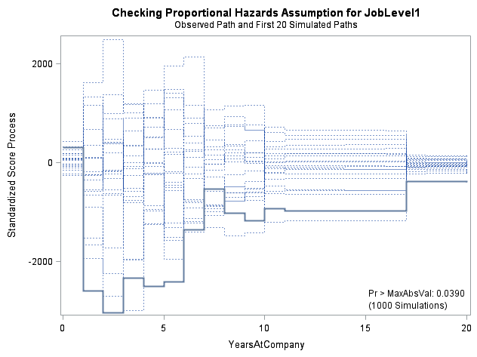

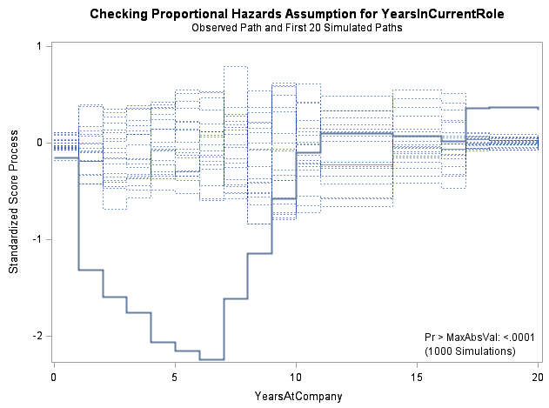

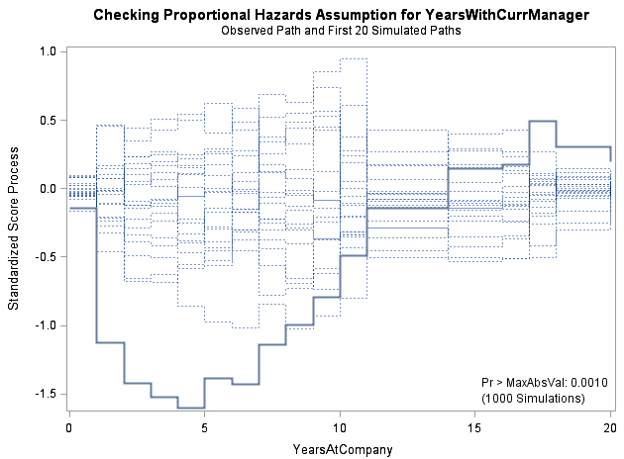

**Shoenfeld Residuals Method**

Residual p-value table

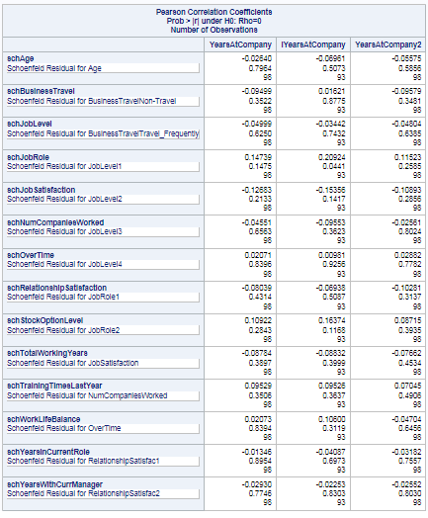

Only Job Role is significant based on residual analysis. So going to combine them together to consider non-proportional problem and run model again.

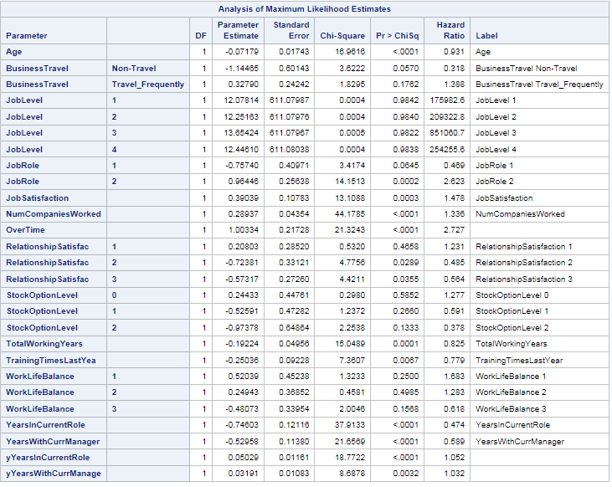

**Conclusion:**

From observation of model performance, considering Years in Current Role and Years with Current Manager are 2 time-dependent variables with non-proportionality.

**5. Business Analysis**

**a. Type=1**

By looking at the final model, which included the cumulative bonus, it shows some business insight.

Age

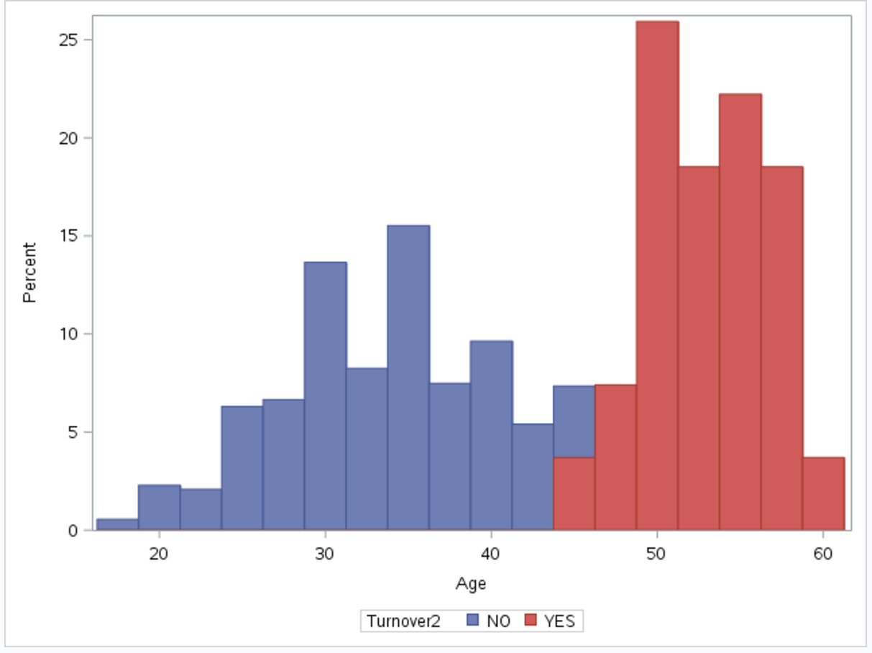

From the histogram chart, there are turnover data when age is greater than 44, it indicates that the people who are older than 44 are more likely to turnover.

Cumulative Bonus

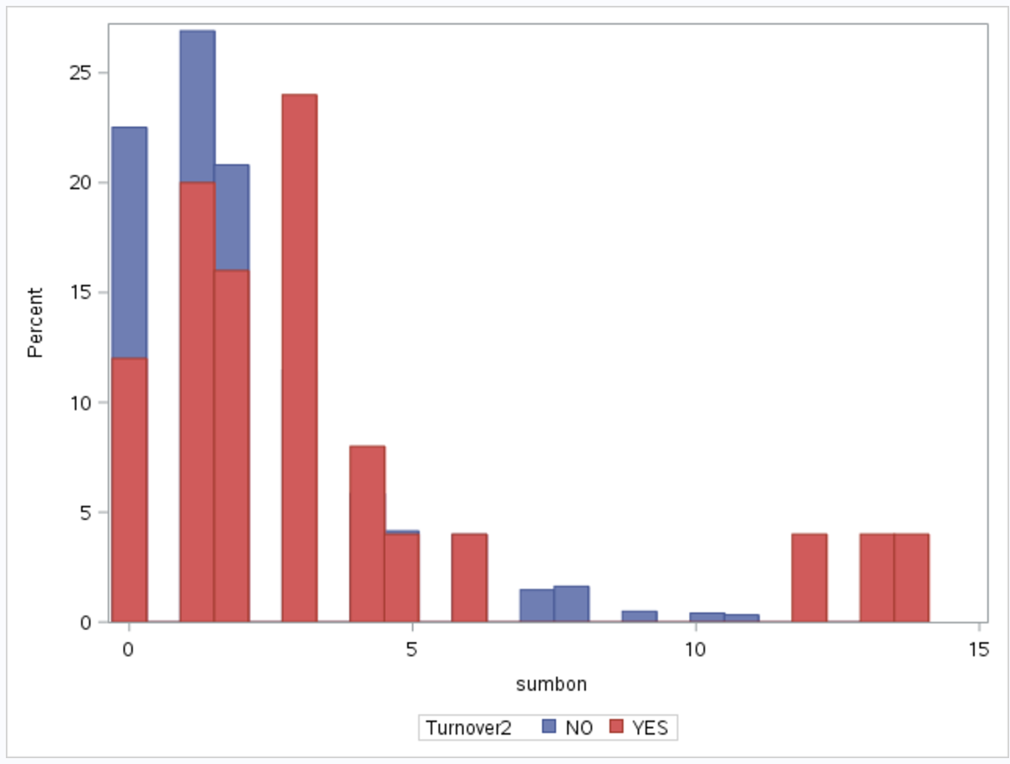

The histogram shows that employees turn over when cumulative bonus is less than 7 or is greater than 13.

TotalWorkingYears

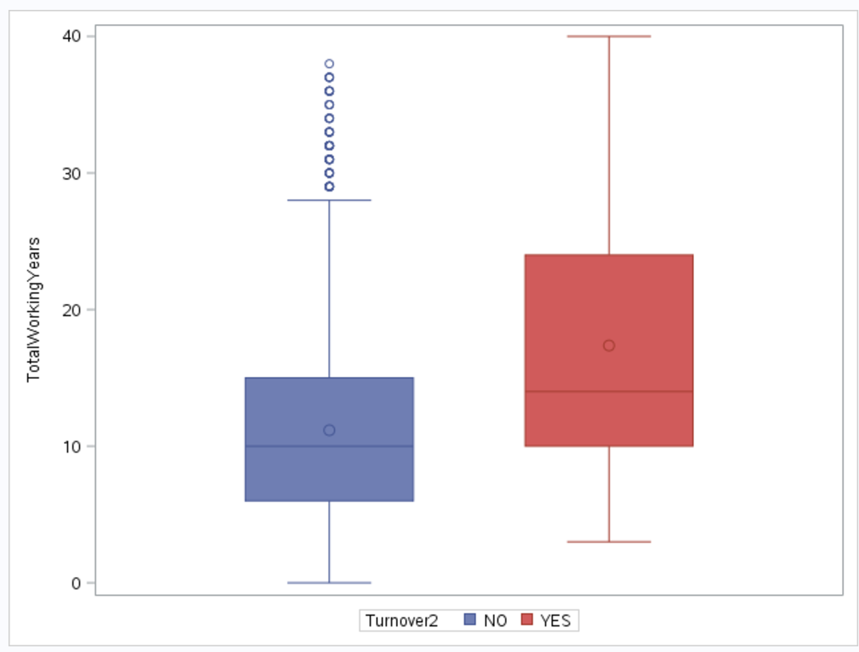

The mean value and median value of total working years is higher in the group or turnover data, means the people with more working experience are tend to turnover.

NumCompaniesWorked

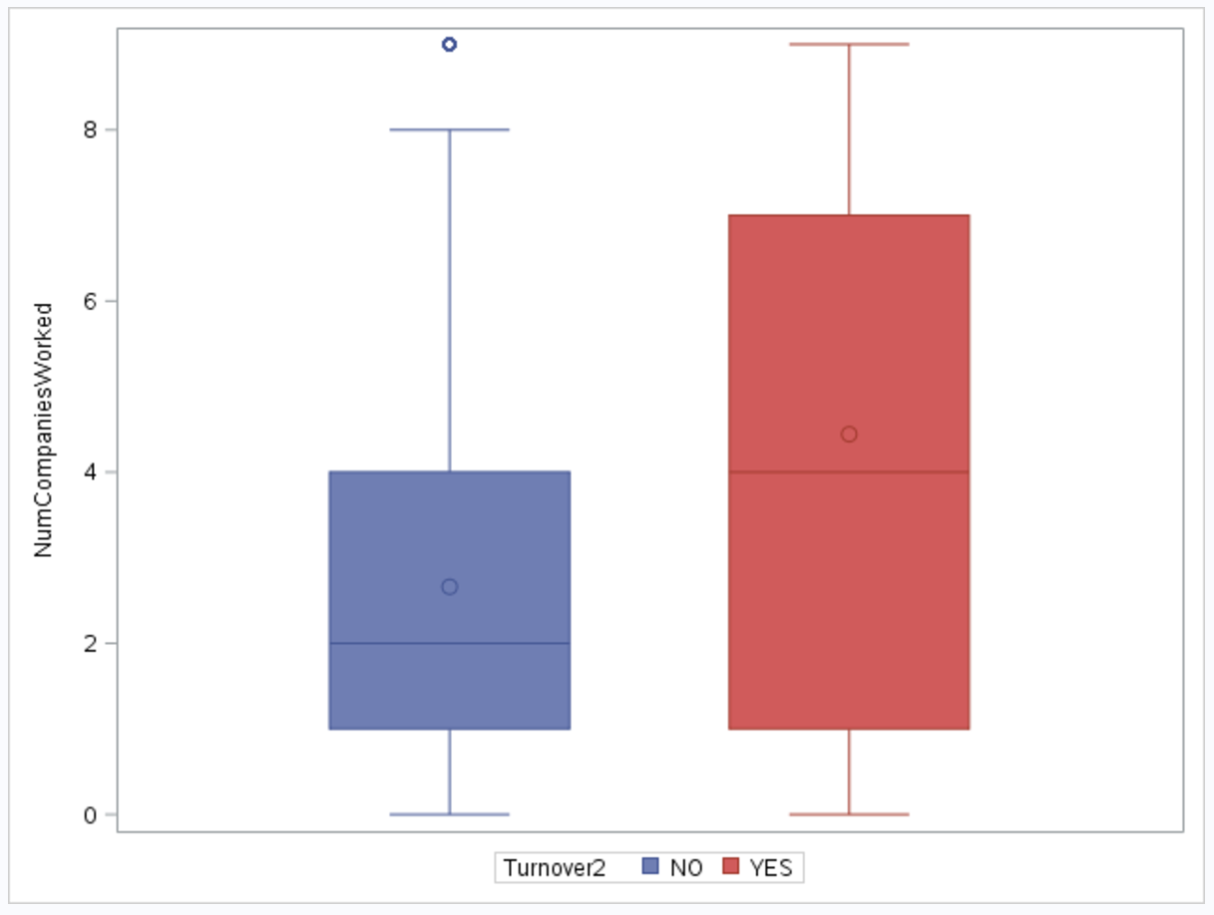

The mean value and median value of the number of companies have worked for is higher in the group or turnover data, means the people have worked on more companies are tend to turnover.

**Conclusion**

So conclude that the people older than 44 are more likely to turnover for type 1, which is retirement, and most of them have more working experience and have worked at more companies; also, they have higher bonus due to their long working years or have the lower bonus due to retirement, for which the observation time is started at the end of their working year.

**b. Type=2**

By looking at the final model, which included the cumulative bonus, it shows some business insight.

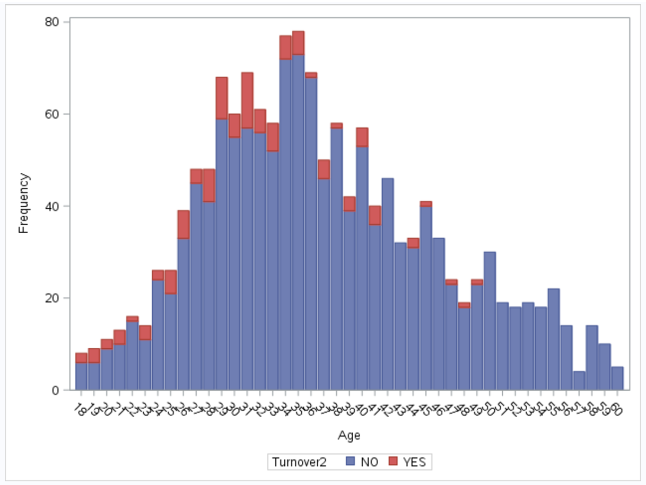

From the histogram chart, there are turnover data when age is less than 49, it indicates that the people who are younger than 49 are more likely to turnover.

Cumulative Bonus

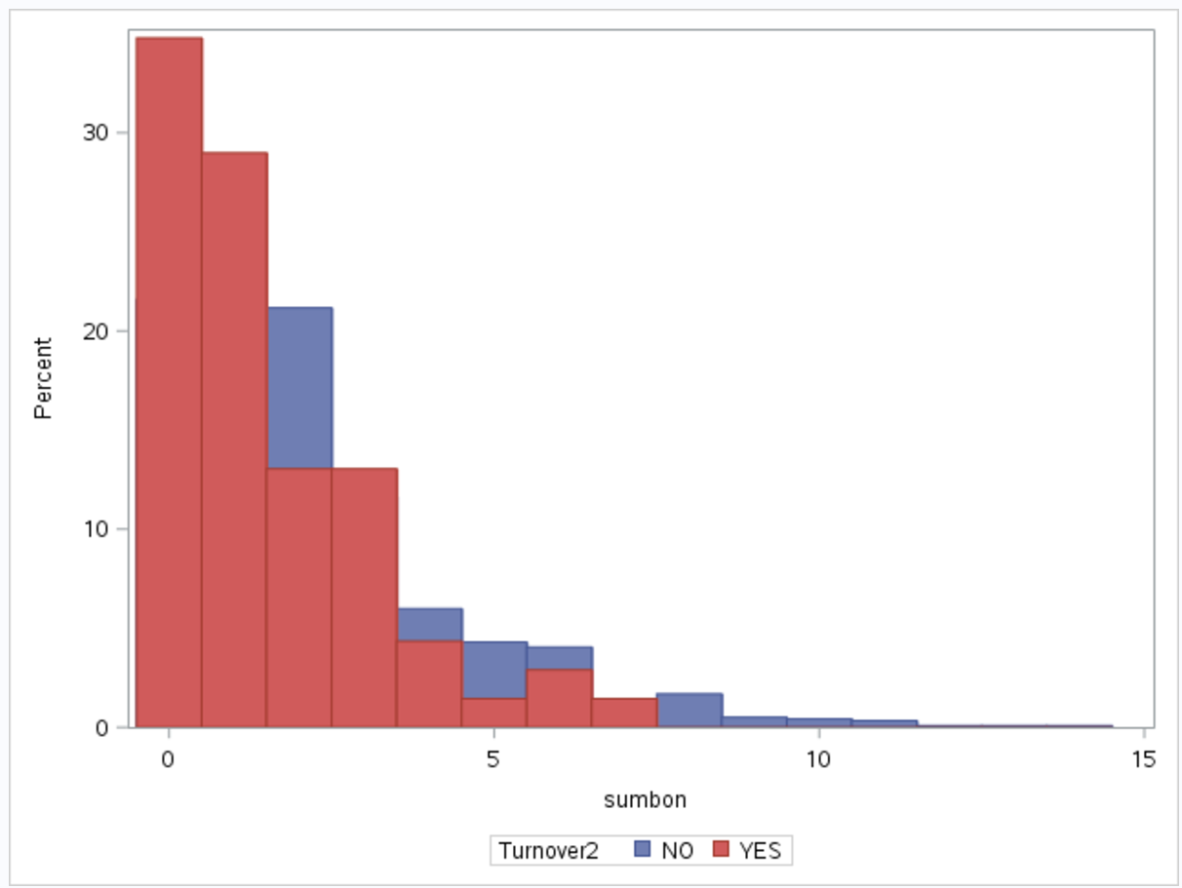

The histogram shows that employees turn over when cumulative bonus is less than 7.

TotalWorkingYears

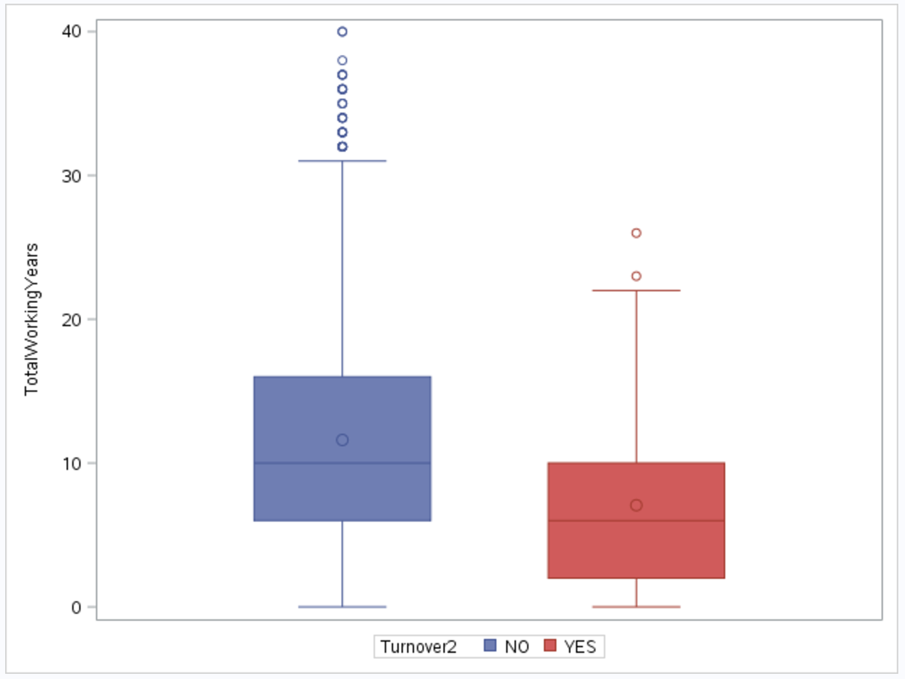

The mean value and median value of total working years is lower in the group or turnover data, means the people with less working experience are tend to turnover.

OverTime

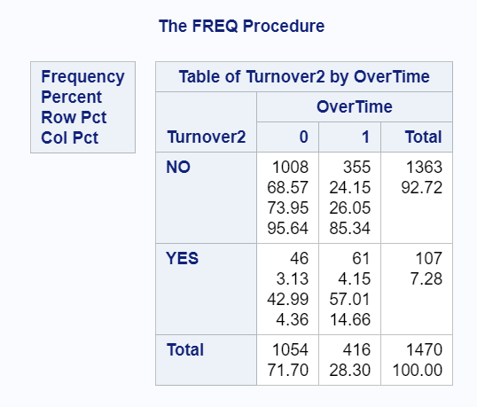

The frequency table shows that people who have experienced overtime work are more likely to turn over (the percentage is 14.66%, which greater than 4.36% in non-overtime group).

Education

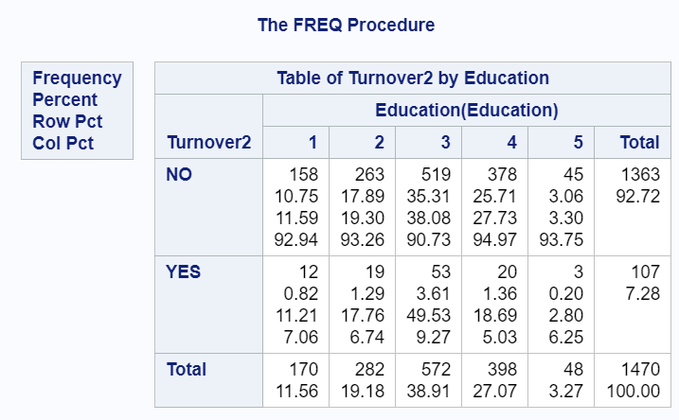

The frequency table shows that people who have the lower and median level of education are more likely to turn over (the percentages are greater when Education=1,2,3).

JobSatisfaction

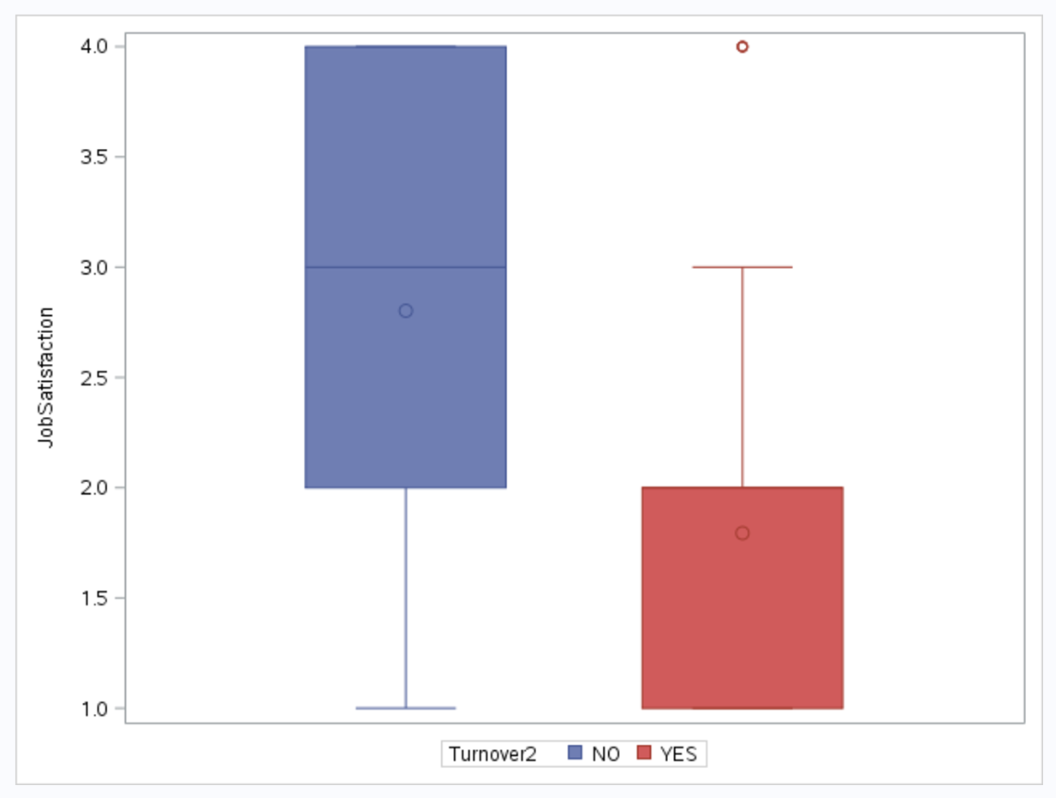

As the box plot shows, the spread range, median value and mean value is lower in the group of turnover data that means people tend to turnover when they are not so satisfied with the company.

**Conclusion**

Those who are before the age of retirement and have less bonus in this company are tend to leave, they have less working experience and have less tolerance for the overtime work, also their education level is median or low and not satisfied with the job.

So those young people might have thought the job is not so idea and want to find a better job and turnover voluntary, and for the older people they may want to retire early;

**c. Type=3**

By looking at the final model, which included the cumulative bonus, it shows some business insight.

Age

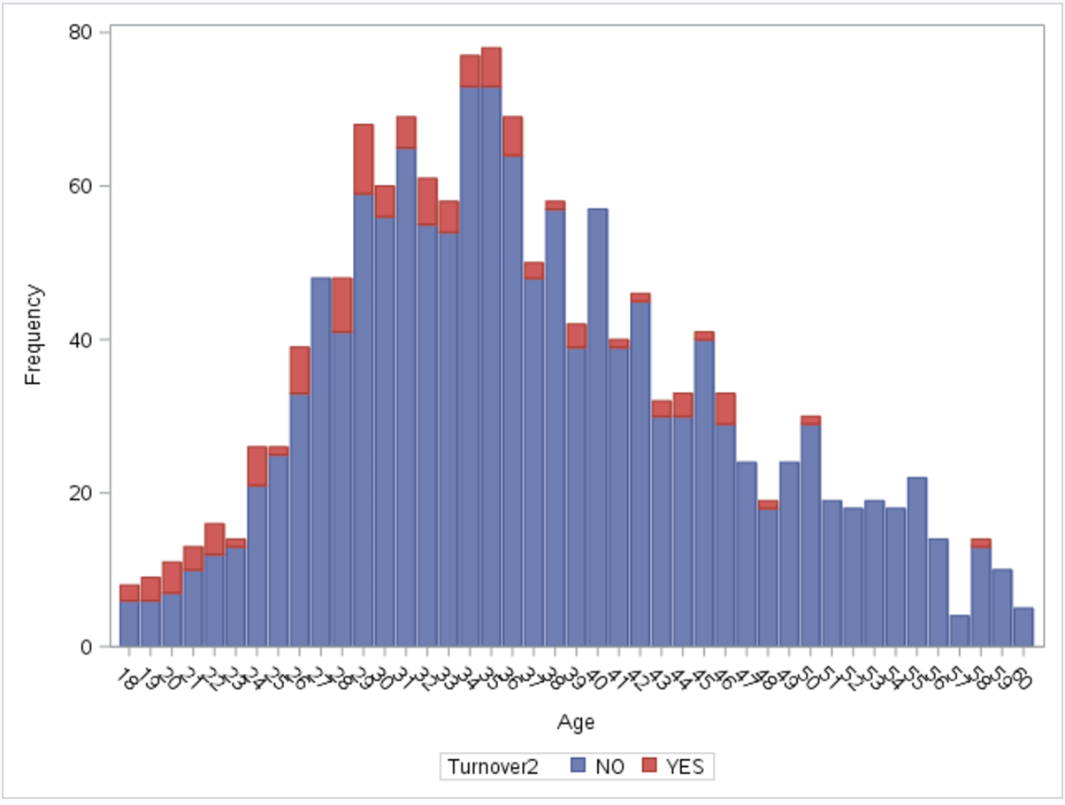

From the histogram chart, there are turnover data when age is less than 50, it indicates that the people who are younger than 50 are more likely to turnover.

Cumulative Bonus

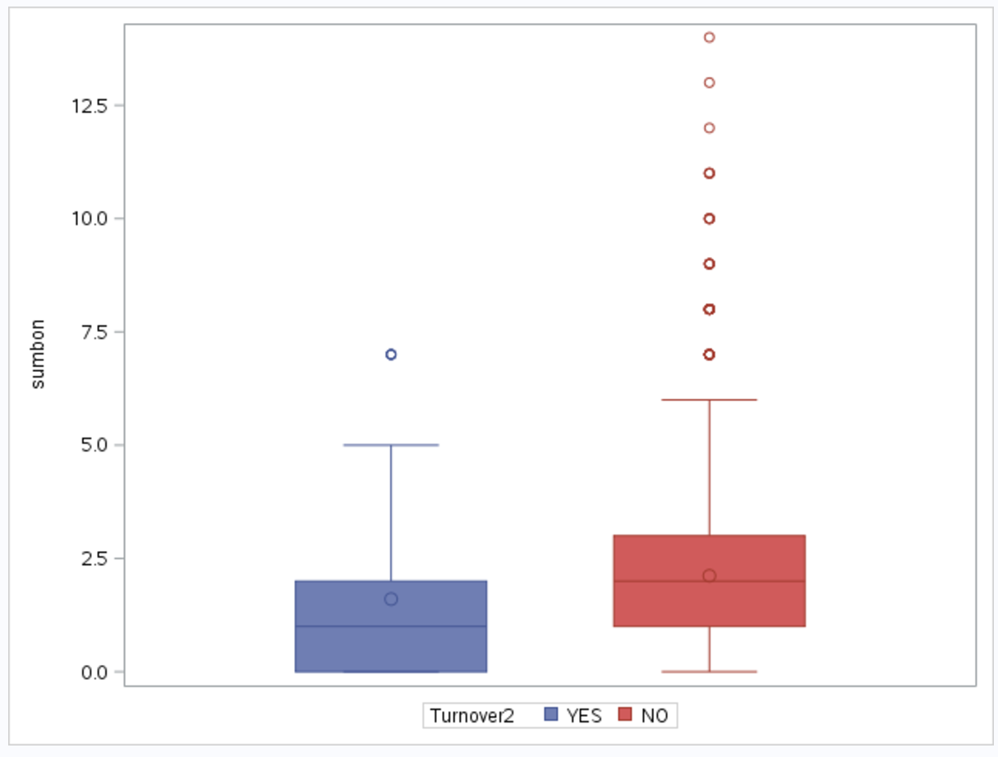

From the box plot, it shows the mean and median values of cumulative bonus are lower in the turnover group data, means people with less bonus are tend to turnover.

TotalWorkingYears

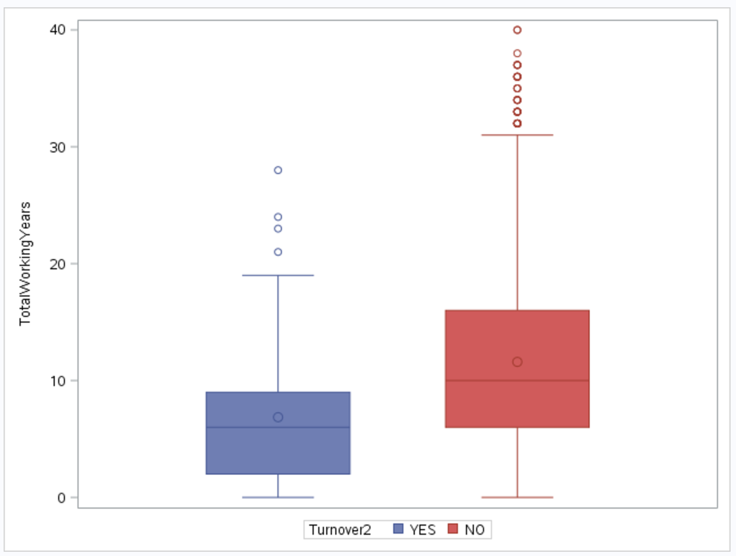

From the box plot, it shows the mean and median values of cumulative bonus are lower in the turnover group data, means people with less working experiences are tend to turnover.

OverTime

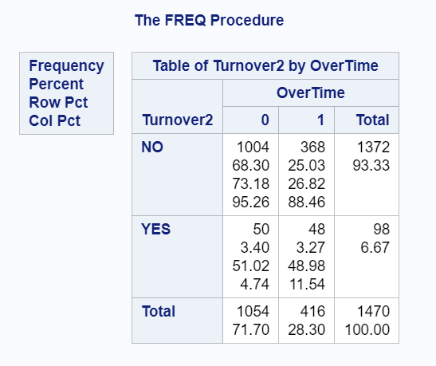

The frequency table shows that people who have experienced overtime work are more likely to turn over (the percentage is 11.54%, which greater than 4.74% in non-overtime group).

Education

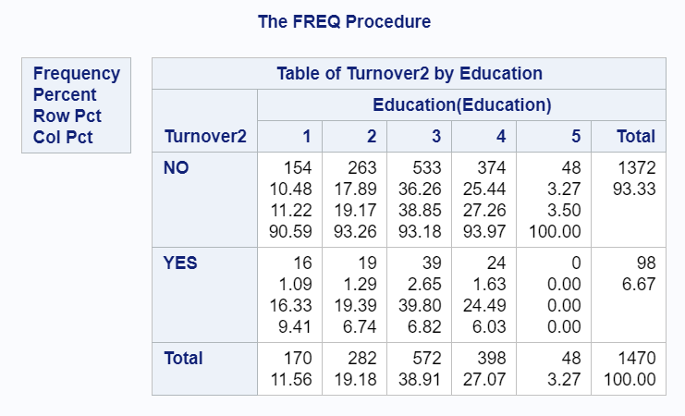

The frequency table shows that people who have lower level of education are more likely to turn over (the percentage is greatest when Education=1).

JobSatisfaction

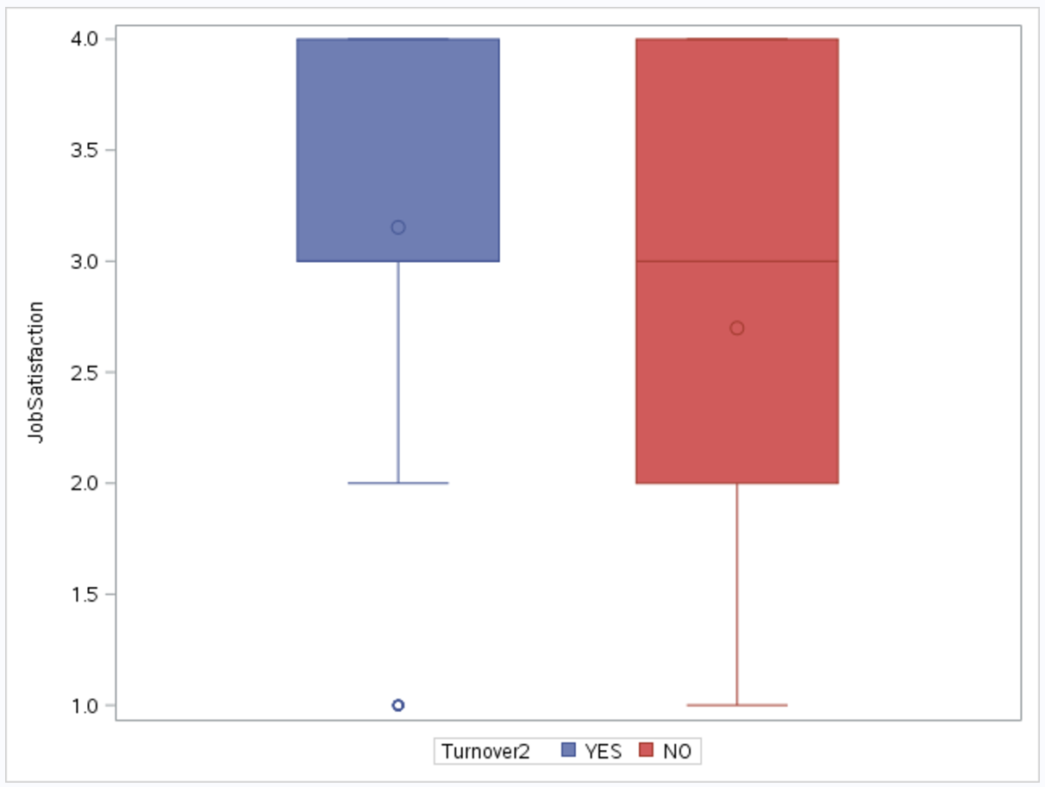

The box plot shows the spread range of JobSatisfaction is smaller and greater in the group of turnover data, it indicates that people with higher job satisfaction are more likely to turnover.

JobRole

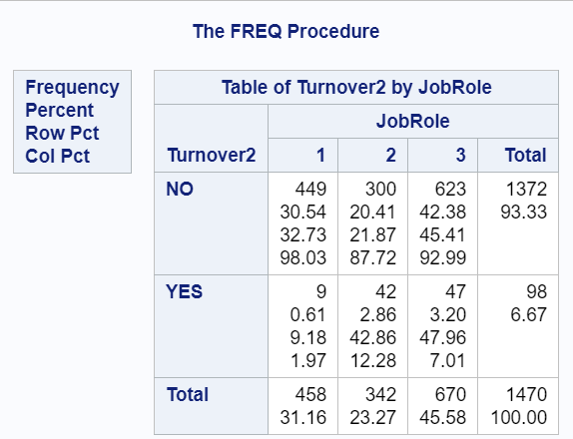

The frequency table shows when job role is 2 (Laboratory Technician and Sales Representative), people are more likely to turn over (the percentage of JobRole=2 is highest 12.28%), means Laboratory Technician and Sales Representative are more likely to leave.

**Conclusion**

The people who is younger than 50 (before retired) and acted as Laboratory Technician or Sales Representative are tending to turn over. They generally have more working experience and satisfied about the job, but earned less bonus and the education level is low;

That might due to those people find themselves well in the job, but they have low working efficiency so they are quit the job involuntary or be fired;

**(Overall) Conclusion**

It is evident from the detail level analysis that have done at each granular level of data, that, there are significant permutation and combination of factors are affecting the employee turn-over at different level of the ladder of the turn over category, so, in a nutshell in this section the project tried to summarize the following key insights which are extremely significant for the company to understand the dynamics of the employee turnover in the company.

1st of all, the project found some independent contributors as follows, Like,

* Attrition rate is higher within the young population of the company on both voluntary and involuntary level. The reasons vary (As seen above in the detail analysis)
* Job role and no of years present in the job role, plays a significant role in the modulation of attrition rate, especially for the young employees.
* Obviously, the income affects the attrition, the lower the income, the more is potential for that employee group to leave the company voluntarily.

However, from the analysis that, it will be very rudimentary to analyze all the events (and the effects of other parameters on them) separately. Rather, found that, if combine the following pair of turn over types (as mentioned below), and then analyze the effect of other parameters on these types it will give more interesting business insights for explaining the dynamics of the attrition behavior for the company, so have made the following combinations.

* Combination 1: Involuntary Resignation and Job Termination
* Combination 2: Retirement and Voluntary Resignation

After the above fusion and combination of event types, there had more insights on how turn over affected in each of these groups. Some key findings are as follows, Like,

* Older people in the company with more experience and more job-related travels are more prone to retirement and voluntary resignation as these people are not that satisfied sacrificing their families and life balance with frequent travels, so they are opting for retirement like situations.
* Stagnancy in current role are also a key factor for voluntary resignation for experienced employees with higher qualifications, on the contrary people with low qualifications are preferring to hold positions as they are satisfied with the mundane work, and thus affecting the productivity of the company these low competency level, older populations are eventually getting terminated anyway.
* Low experience and lack of performance due to incompetence is also a key factor of involuntary resignation or job termination.
* Finally, have seen that in majority of the cases, bonus does not pay a significant role for voluntary resignation or termination or involuntary resignation, however, the project found an interesting business insight, that, cumulative bonus and lack of lesser bonus for many years is creating an impact for retirement population as many highly experienced people are opting for retirement as their cumulative bonus is not giving them any edge, so they are not willing to put more years in the company and retiring

**Recommendations**

After carefully analyzing and concluding all the different levels of impacts for turn overrate, there are also proactively constructed few recommendations for the HR and higher management of the ‘Fermalogis’ company, which will help the company in long run, if they monitor and implement these recommendations in a regular manner and take proactive actions to mitigate risk associated with the different level or categories of employee attrition

* We have seen, that more competent employees are more prone leave the company voluntarily irrespective of young or old, when there is a lack of challenging assignments, stagnancy at work. So recommend the management to engage more with these population, carefully monitor their job growth, aspirational needs, and periodically make possible arrangement to provide more assignments which are of high impact nature to these people. Reward and recognition, empowerment, autonomy of work, sound line- manger who can listen to these people’s need are also key to avoid attrition for these level of people.
* We have also seen from the analysis that, a significant population of employee are at risk of termination, either, due to lesser contribution in productivity and value add (like older population with lesser qualification, doing mundane work and not re-trainable or capable of lateral movement in the company) or due to lack of experience and incompetence (like younger population with mediocre qualification). And recommending the higher management and HR of the company to apply the following principles for these people
  + 1. For older population with less competence, someone has been in the company for a long time and doing same mundane tasks for years, company should figure out innovative ways to re-train these populations so they can be better utilized at a higher productivity level.
  + 2. For the younger population with low competence, HR needs to be very strict in recruitment to avoid these population and filter them carefully in the selection process to avoid HIRE and FIRE scenarios.
* Finally, have seen a significant population of the employee on the verge of retirement for various reason and situation (as have already explained above), Some of these people are highly qualified and extremely knowledgeable and experienced and might leave a void in their respective departments once they retire. To avoid such situation management associated to these people, should think of seamless transition of these people with other competent employees from the organization, way ahead of the retirement, so there is ample opportunity for proper knowledge transfer without affecting the business as usual.
* Last but not the least, can say that, although attrition is ‘inevitable’ at any point of an organization, but if management and HR team pays careful attention towards the insights and recommendation the report has provided above, and monitor them on a regular basis, these factors can be managed significantly better, and will have lesser impacts towards the overall productivity of the workforce.

Appendix

Variables explanation

|  |  |  |
| --- | --- | --- |
| **Attribute-Name** | **Attribute Definition** | **Sample value(s)** |
| Age | age of the employee when this dataset was created | 41 |
| Turnover | shows whether the employee left the company or not | ‘Yes’ |
| Type | type of turnover | 0: No Turnover  1: Retirement  2: Voluntary Resignation  3: Involuntary Resignation  4: Job Termination, Employee is fired |
| BusinessTravel | shows how much travel employee makes | Travel_Rarely |
| DailyRate | daily compensation of employee before any cuts/taxes | 1102 |
| Department | shows the department of the employee when this dataset was created | Sales |
| DistanceFromHome | commuting distance for the employee in miles | 1 |
| Education | 1 - 'Below College' , 2 -'College',3 - 'Bachelor',4 - 'Master',5 - 'Doctor' | 2 |
| EducationField | shows the education field of the employee | Life Sciences |
| EmployeeCount | a field used for aggregation calculations | 1 |
| EmloyeeNumber | the ID of the employee | 1 |
| EnvironmentSatisfaction | a score showing how much the employee is satisfied with company's facilities (1 - 'Low',2 - 'Medium',3 - 'High', 4 - 'Very High') | 2 |
| Gender | shows the gender of the employee | Female |
| HourlyRate | hourly compensation of employee before any cuts/taxes | 94 |
| JobInvolvement | a score given to the employee by supervisors how much the employee is involved in company's operations (1 -'Low',2 -'Medium',3 -'High',4 -'Very High') | 3 |
| JobRole | shows the job role of the employee in the company | Sales Executive |
|  |  |  |
| JobLevel | shows the management level of the employee | 2 |
| JobSatisfaction | shows the last survey result of the employee about his\her job satisfaction | 4 |
| MaritalStatus | shows the marital status of the company | Single |
| MonthlyIncome | shows the monthly income of the employee | 5993 |
| MontlyRate | monthly compensation of employee before any cuts/taxes | 19479 |
| NumCompaniesWorked | the number of companies the employee worked before starting in the company | 8 |
| Over18 | shows whether the employee is over 18 years old | Y |
| OverTime | shows whether employee works overtime more than 10 hours a week | Yes |
| PercentSalaryHike | shows the agreed yearly salary rise percent | 11 |
| PerformanceRating | a score given to the employee by supervisors how good was the performance of the employee last year (1 -'Low',2 - 'Good',3 -'Excellent',4 - 'Outstanding') | 3 |
| RelationshipSatisfaction | shows the last survey result of the employee about his\her satisfaction with other employees in the company(1- 'Low',2- 'Medium',3- 'High',4- 'Very High') | 1 |
| StandardHours | number of hours employee works for one payroll period (two weeks) | 80 |
| StockOptionLevel | shows the stock option for the employee. If your analyses give significant results for this variable, you can refer to that group as "employees having stock option level x" | 0 |
| TotalWorkingYears | shows the time the employee worked as a professional (at any company) | 8 |
| TrainingTimesLastYear | shows the number of training programs employee has attended last year | 0 |
| WorkLifeBalance | shows the employee satisfaction of the work load (4 is the highest satisfaction level) (1- 'Bad',2 -'Good',3- 'Better',4 -'Best') | 1 |
| YearsAtCompany | Tenure at the company | 6 |
| YearsInCurrentRole | the number of years employee works in the current position | 4 |
| YearsSinceLastPromotion | shows the number of years passed since the last promotion | 0 |
| YearsWithCurrentManager | Shows the number of years with the current supervisor. | 5 |
| bonus_1-40 | Shows whether the employee received bonus payments in the last 40 years. bonus_1 is last year | 0…… |

SAS Code

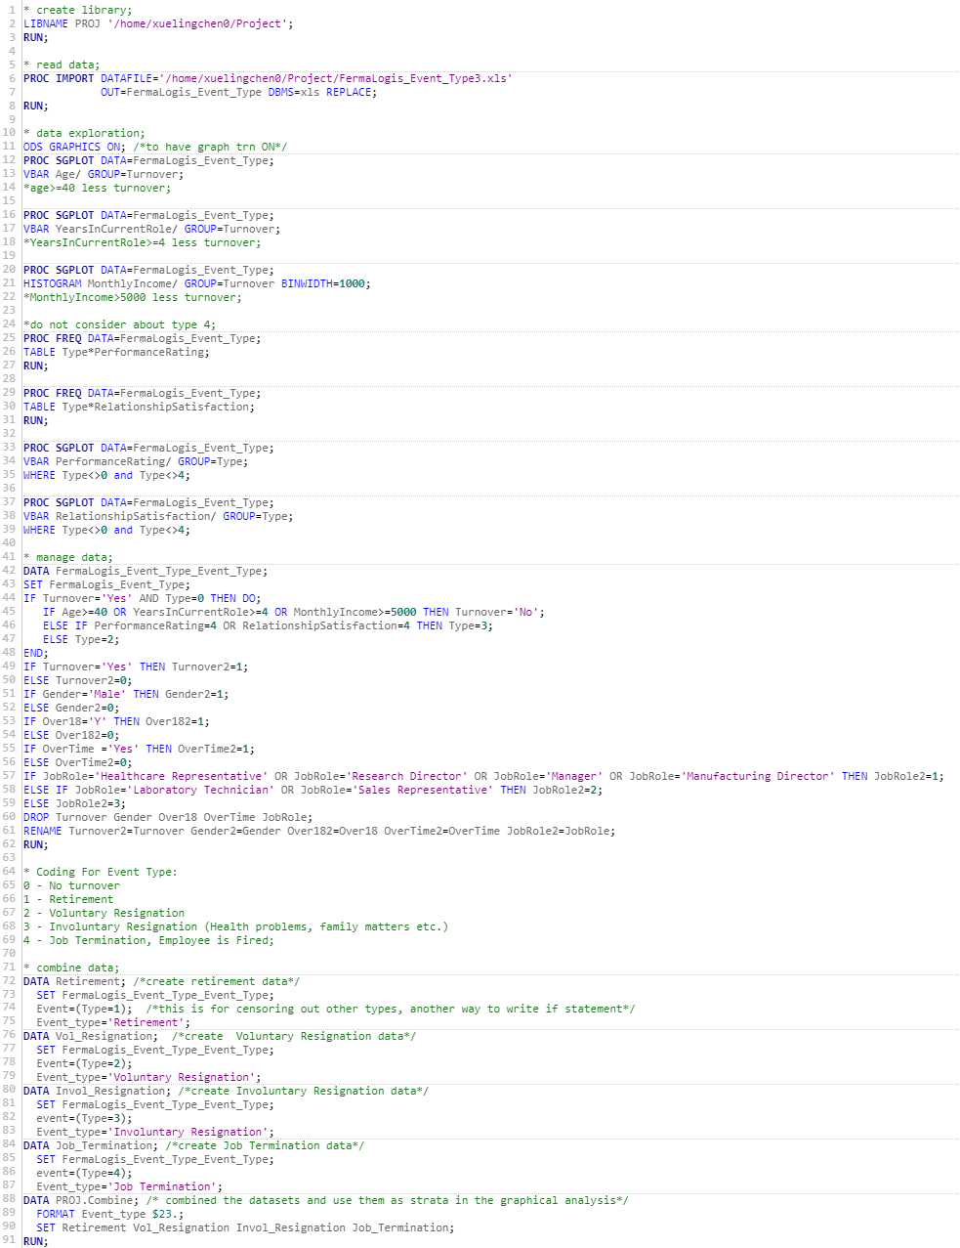

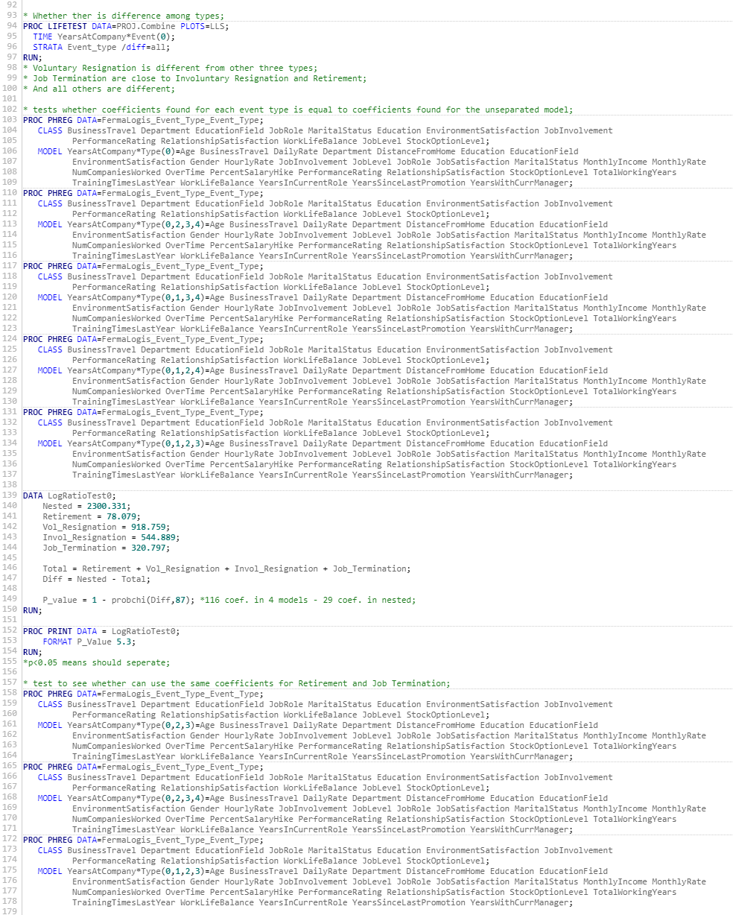

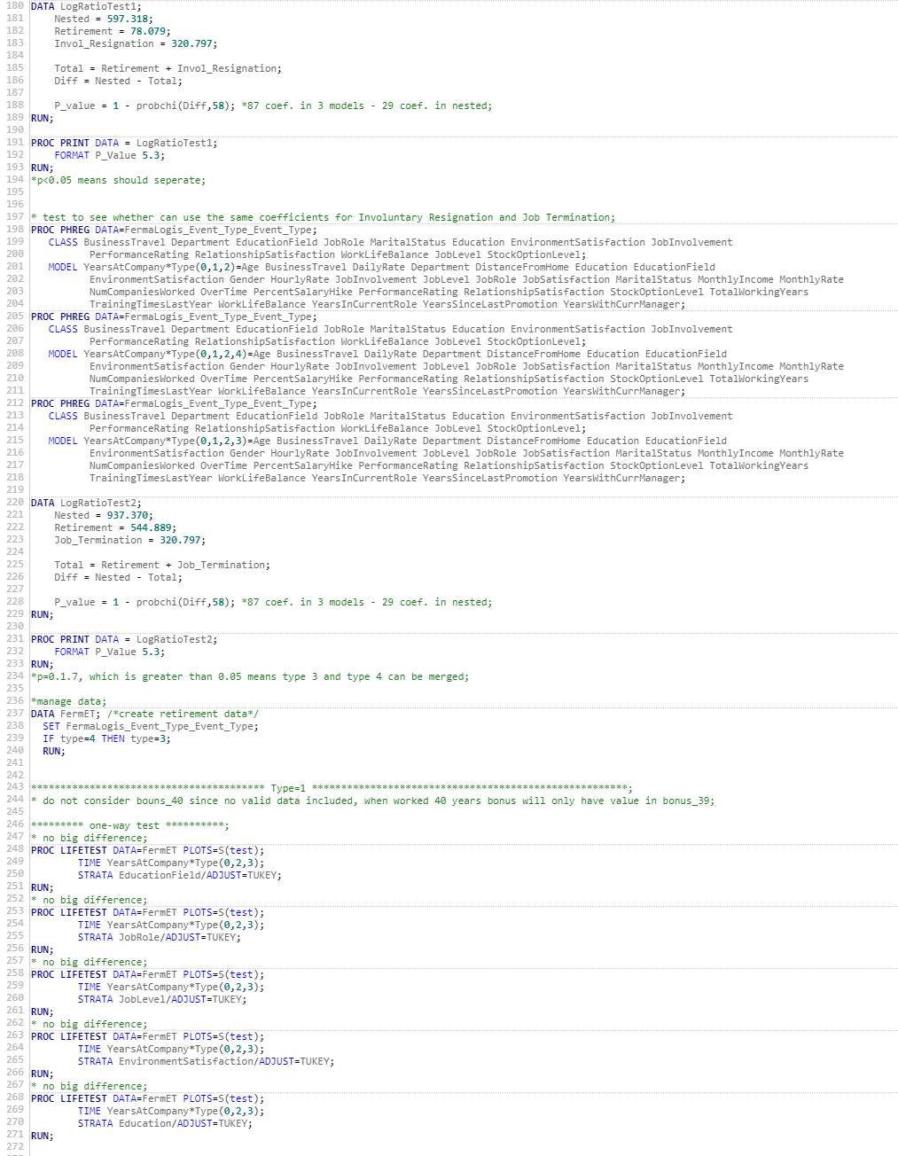





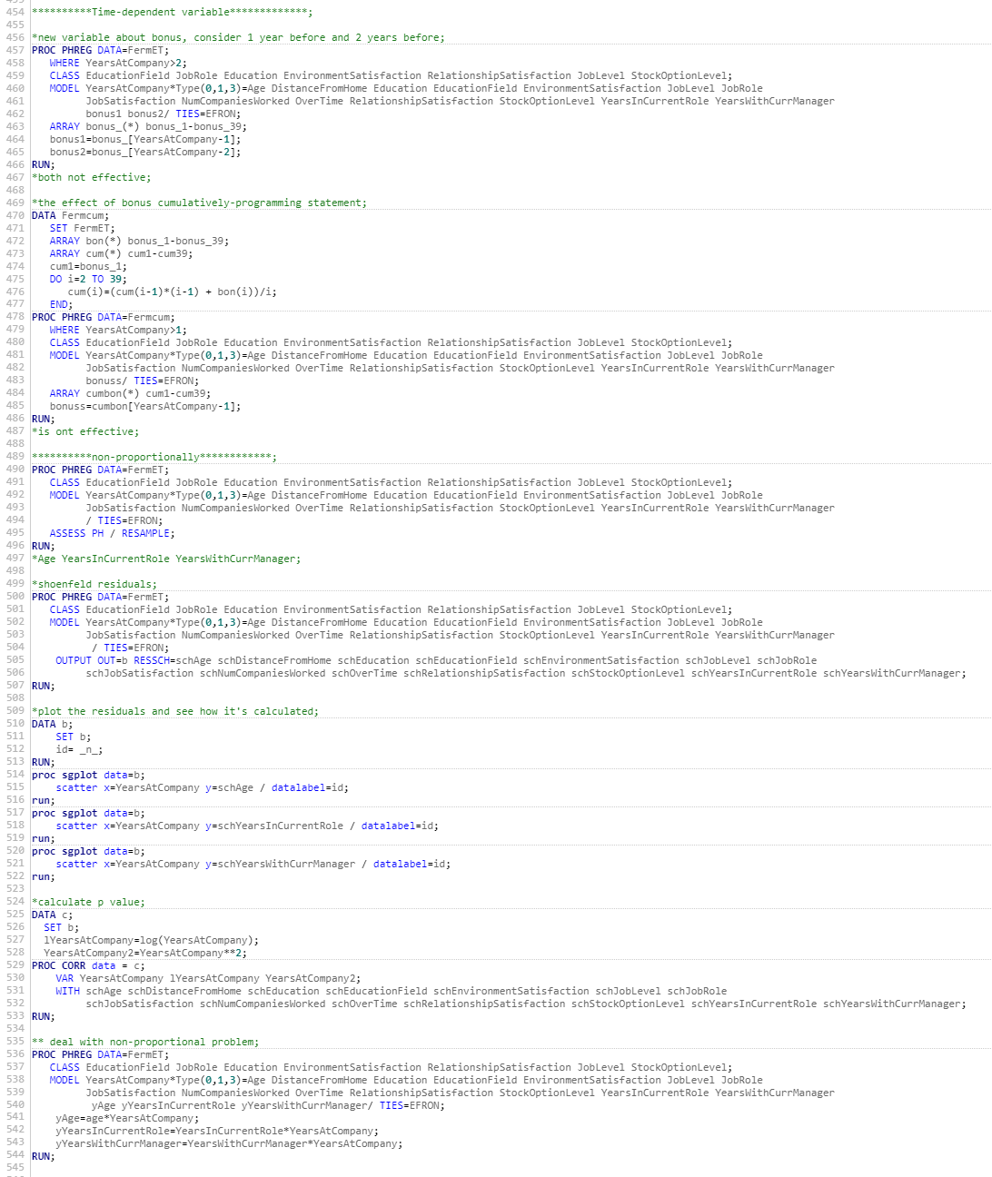

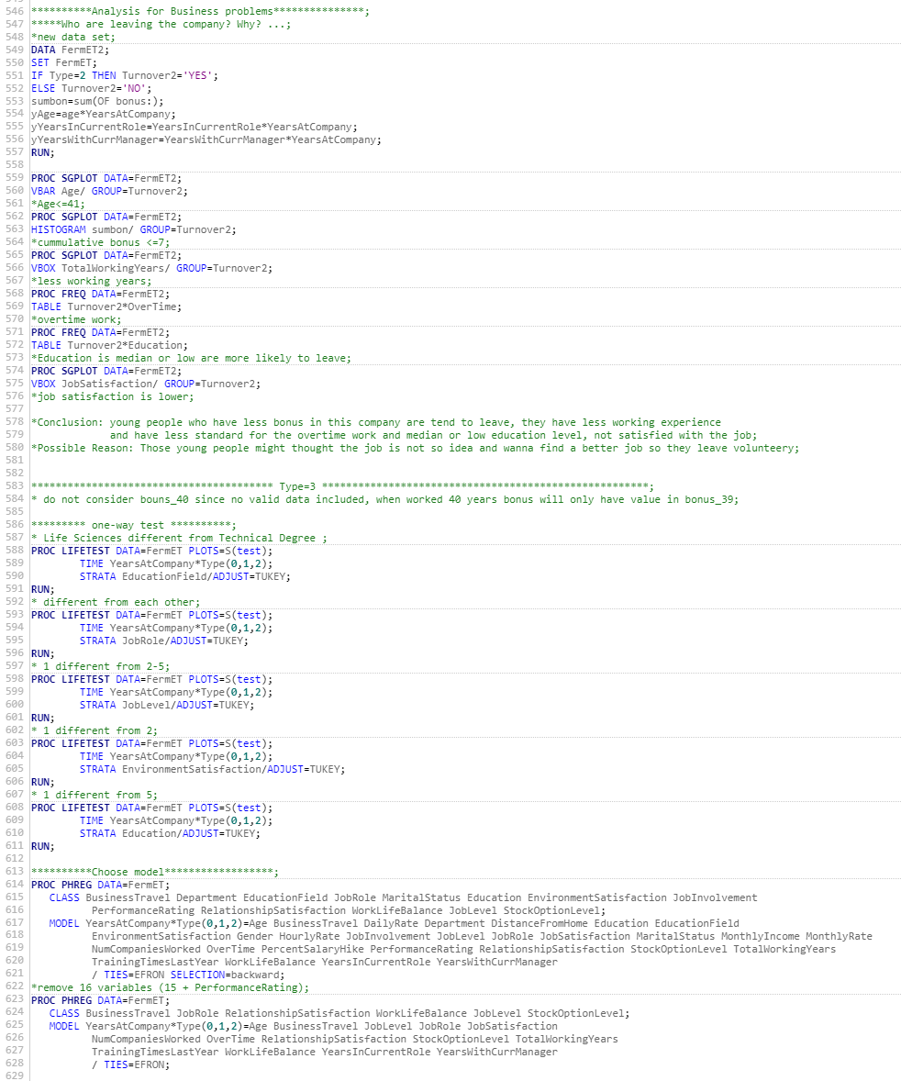

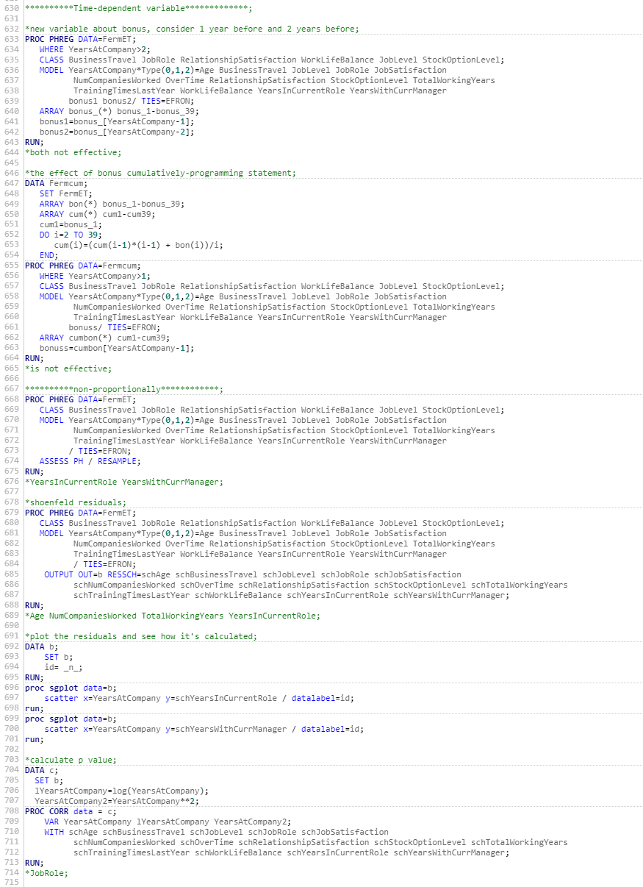

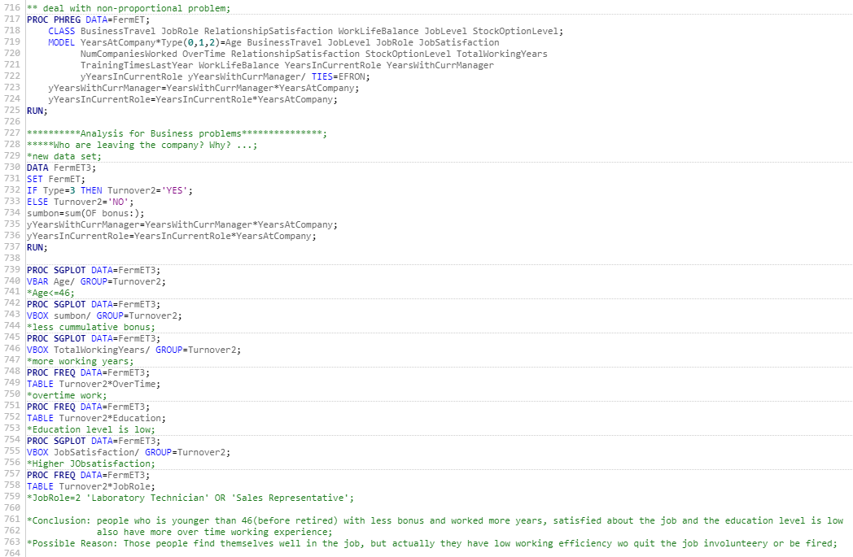

References

Arda Zuber, (2017). OPIM-5894 - Survival Analysis with SAS Course Materials. UConn School of Business.

Delwiche, L. D., & Slaughter, S. J. (2012). The Little SAS Book: A Primer: A Primer. SAS Institute.

Allison, P. D. (2010). Survival analysis using SAS: a practical guide. Sas Institute.